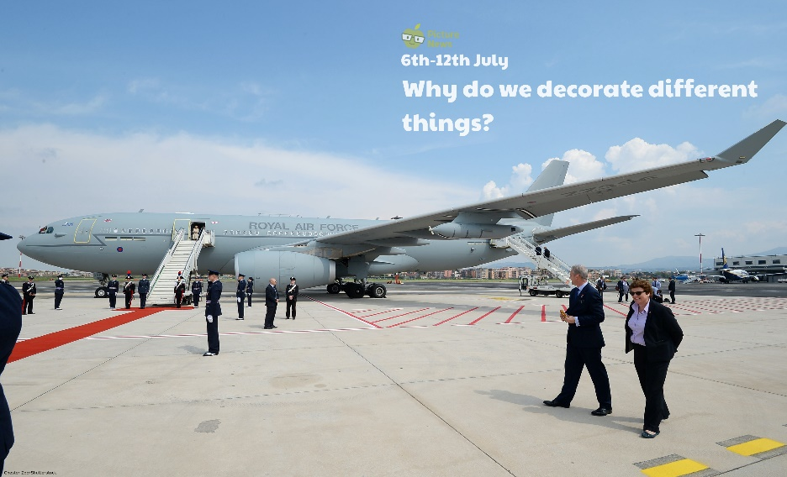

**Use this sheet to let a grown-up write down all your thoughts on this week’s story.**

* What can you see? Who could be travelling on this plane?
* Do you know who the Prime Minister is? Can you name any members of the Royal Family?
* Do you think having the colour red, white and blue on this plane is a good idea? Do you think the plane will look better?
* Can you think of something you have decorated? What did you decorate? How did you decorate it?