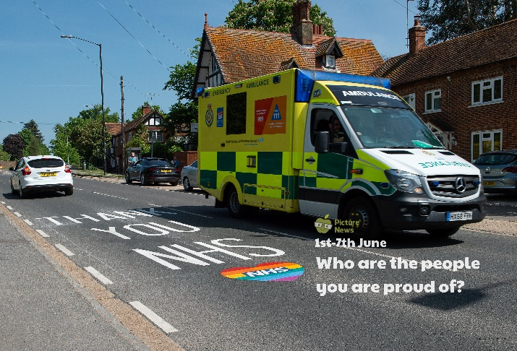

**Use this sheet to let a grown-up write down all your thoughts on this week’s story.**

* What can you see? What is an ambulance?
* Would you like to be a doctor, nurse or paramedic? Why/why not?
* What kind of job would you like when your older?
* Who are you proud of? Why?