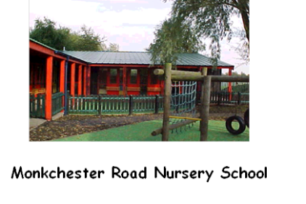
Monkchester Road Nursery School and Playgroup
Plans for opening to more pupils in June and July 2020

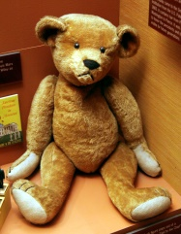
We are finalising plans to open for more pupils soon. We hope these questions and answers will help explain how things might look and what will change.

What will Nursery and Playgroup look like when children return in June/July?

When children return to Nursery and Playgroup, the building and classrooms will look different from what children are used to as we have removed some equipment and soft furnishings for their safety. You can look at photographs on our website to see what classrooms look like before you bring your child back to Nursery.
We have put markings around school to help staff and parents maintain social distancing rules. We are asking everyone to try to walk to the left of pathways to help keep their distance from others. We have also brought in a one-way system for parents to walk around the garden when they drop off and collect their children.
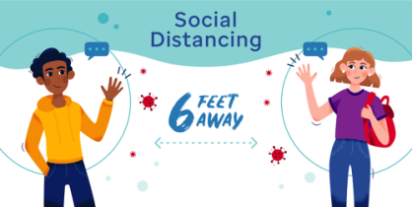
Will my child have to keep their 2 metres social distance from others?

The Government is NOT expecting children who are under 5 years of age to stay socially distant away from each other. We cannot guarantee that children will stay 2 metres away from each other at all times.
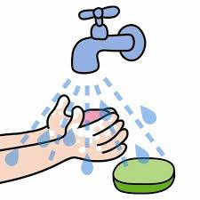
When parents/carers bring their children in to school, we are asking them to hold their child’s hand at all times. This is so that children do not get too close to other parents and children. There is a one way system around the school now and we need all parents/carers to keep to the system and follow the arrows around the building when they come to school at drop off and pick up times.

Should my child wear a face mask and bring hand sanitiser from home?

NO! Children do not need to wear facemasks and they do not need hand sanitiser. Staff will make sure that children wash their hands regularly during the day/session. Staff will teach children about the importance of washing their hands regularly.

Who will teach my child when they return to Nursery/Playgroup in June/July?

As far as possible, we will make sure that children work with staff they know and at least one of their keyworkers will be with them for most of the time.
We have made sure that we teach children in much smaller groups than usual with a higher staff to child ratio than normal. This is to help keep everyone as safe as possible.
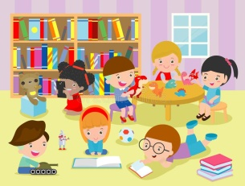
The Government suggests children are taught in small ‘Bubble Groups’ and that the groups are kept separate from each other throughout their sessions. The idea is that teaching in separate groups will stop the possible spread of infection across the school. This should not be very much different from what our children are used to.

Where will my child’s classroom be?

We will only be using three classrooms in Nursery and one in Playgroup. Children might not be in their usual classroom base but will be in the same building with staff and friends they already know.
We will teach children from Class 1 and 2 in Classroom 2 (as we are only expecting 8 or 9 children back initially). They will be Bubble Group 2
We will teach children from Class 3 and 4 in their usual rooms (and we are only expecting 11 children back initially.) They will be Bubble Group 3
We will be teaching Playgroup children in Playgroup Room 1 and we are only expecting 4 or 5 children back initially. This group will be PG Bubble Group 1.

What time will Nursery and Playgroup start?

Each Bubble Group will have a different drop off time in the morning so that we can keep these groups separate throughout the day.
We ask parents and carers to make sure they come in to Nursery/Playgroup at their set time so that there are not too many parents and children all coming on site at the same time. We have left a 15 minute gap in between each groups’ drop off time. This staggered start to the day gives staff time to meet their children in the garden and then bring the children inside to wash their hands before the next group arrives.
We can only allow one parent/carer from each family on site at the same time to reduce numbers of people in the grounds at any time. Parents/carers and general visitors should not enter the school buildings.
Drop off points/times will be:
9.00 a.m. for Class 1 and 2 (Bubble Group 2) - Parents/carers drop them off in the Willow area beside the sandpit, outside Class 1.
9.15 a.m. for Class 3 and 4 (Bubble Group 3) – Parents drop them off in the Jabadeo area outside Class 3 and 4.
9.30 a.m. for Playgroup children - Parents drop them off in the Playgroup yard near the playhouse.
If these times are inconvenient for your working hours, please speak to a member of staff and we will see if we can make any alterations that might help you.
If parents/carers and children are late for the start of their session, we must ask them to wait until after 10.00 a.m.
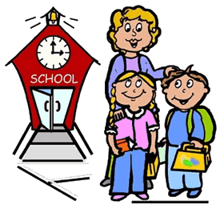
before coming on site. Please only come on site once all of the other children have gone to their classrooms and the other parents/carers have left. After this time, parents/carers can make their way to the main door and press the buzzer. Mrs. Grant or Mrs. Innes will then sign your child in and take them to their classrooms.

What time will Nursery and Playgroup finish?

The finish time for children is different depending on their age and their Bubble Group. We have staggered times for pick up as well to reduce numbers on site and make sure all children have the right length of session.
If you have a 30-hour code, for free childcare, then your child can stay in Nursery for 6 hours per day.
For parents who do not have a 30-hour code, children can only stay for a 3 hours session in the mornings. If you are a critical worker but need more than 3 hours childcare per day, please call school and talk to us and we will try to help if we can.
These timings are a temporary change compared to what we usually do at Monkchester Road Nursery. We hope this change is just for June and July as it is to reduce risks for staff and children.
All of our playgroup children will have their usual 3-hour session but this will be in the mornings only during June and July. If you usually have an afternoon place and want your child to come back to Playgroup you can get in touch with us and we will try to offer you a morning session instead.
Parents/Carers collect children at these times:
12.30 p.m. for Bubble Group 1 (playgroup parents)
12.00 Noon for Bubble Group 2 (for parents who do not have 30 hour code)
3.00 p.m. for Bubble Group 2 (for parents who have the 30 hour code)
12.15 p.m. for Bubble Group 3 (for parents who do not have 30 hour code)
3.15 p.m. for Bubble Group 3 (for parents who have 30 hour code)
Parents/Carers pick up their children from the same area in the garden where they drop children off each morning.
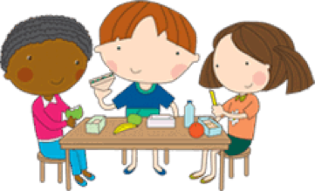
Staff will make sure every child washes their hands before they go out to meet their parents at the end of their session.

Will my child have their lunch in Nursery/Playgroup during June and July?

We are not providing hot meals at Nursery during June and July. This is to reduce risks for children and staff.
Children of parents who have a 30 hour code - should bring a packed lunch in to Nursery with them each morning.
Packed lunches should be stored in a fabric free, plastic container that staff can wipe clean quickly and easily.

Staff will supervise children eating their packed lunches in their classrooms to avoid unnecessary movement around Nursery and so that different groups don’t have to share the lunch hall. Parents of children who usually have a Free School Meal will continue to receive vouchers for these on a weekly basis. Parents/carers receive these vouchers even if their children do not return to Nursery. IF children do come back to Nursery but are only having a 3 hour session, they will NOT stay for lunch on site.
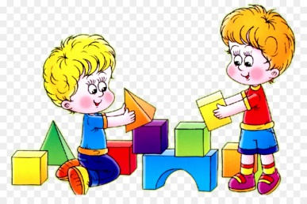
What will my child do during their time at Nursery/Playgroup in June and July?

We will try to provide the best opportunities for every child that we can during June and July but activities may be different from usual depending on the new safety and hygiene standards we have to follow.
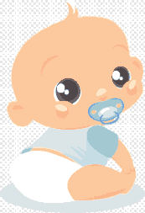
The government recommend outdoor play as much as possible just now because the Covid -19 virus is less likely to spread outdoors. The outdoor gardens and playgrounds also give children more space to play freely. Each group will have a separate time to play indoors and outdoors during the day so that they do not mix with other groups. While playing outdoors, staff will supervise and work with children as they usually do. We will focus on children’s personal, social and emotional well-being when they come back to Nursery/Playgroup and we will try to help them catch up on anything they have missed while they have been away.

What can my child bring in to Nursery and Playgroup with them?

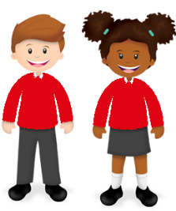
Children should not bring anything from home with them when they come in to Nursery/Playgroup (during June and July). They should not bring toys, blankets, bikes or scooters in to Nursery/Playgroup. We ask parents to take buggies and prams back home with them during the day and NOT leave them on site. IF children usually have a dummy while they are in playgroup, this is fine and parents should give it to staff when they drop their children off. Staff will store these safely and hygienically until children need them.

Will my child have to wear a uniform when they attend Nursery/Playgroup?

Your child does not have to wear a uniform when they come back in to Nursery/Playgroup, but they can IF you want them to. As usual, we leave it up to each parent/carer to decide if they want their child to wear uniform. It is optional.
However, the government suggests that children change their clothes when they get home and wear clean clothes every day. This is to try to prevent the virus spreading from home to school and/or from school to home.
If any parents/carers find it difficult to make sure children wear clean clothes each day, we will help them as much as we can. If you might find this difficult, for any reason, please phone Nursery/Playgroup and speak to a member of staff for support. We have plans in place that will help parents/carers if they need any support with this.

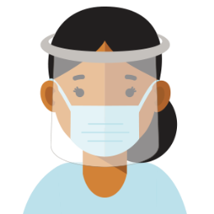
Will staff be wearing Personal Protective Equipment (PPE) when they work with my child?

Each individual member of staff can choose whether and what PPE they wear while they work in Nursery/Playgroup. This will depend on their own personal needs/circumstances and those of the children they care for and look after. All/Every member of staff will wear PPE if they need to provide intimate care for children (e.g. change nappies) or if they give First aid or provide medical assistance.
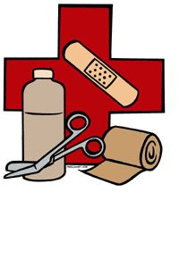
What happens if my child is upset or needs First Aid while they are at Nursery and Playgroup?

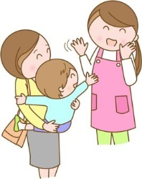
Staff will carry out First Aid and give medication as they always do. They may wear additional PPE in in some cases. If your child is upset, staff will care for them and pacify them as they usually do.

What if my child gets upset when they have to leave me in the mornings when I drop them off?

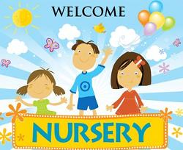
If you are concerned that your child might be upset when they leave you in the mornings and that staff may need to intervene, then please contact us before your child returns to Nursery/Playgroup. We will talk to you personally to explain what we will do if this happens and we can plan what to do together. Staff will help as much as they can to prepare for your child coming back to Nursery/Playgroup and they will work with you to make it as easy as possible for your child to return.

Can I just bring my child in to Nursery and Playgroup - any day, any time?

NO! - Unfortunately, because of the current situation and all the difficulties this brings, parents will need to contact us before they choose to bring their child back to Nursery/Playgroup. At first, we will be opening to vulnerable children, the children of critical workers and to those parents who have already told us they want their child to come back to Nursery/Playgroup.
If you are not in any of these groups and you have just decided that you would like your child to come back to Nursery/Playgroup, you will need to telephone or email us to let us know.
During June and July, when we open for more children, we will be running a ‘booking-in’ service and parents need to tell us in advance if they want their child to come back to Nursery.
Parents of vulnerable children and critical workers need to give us at least a day’s notice if they wish to bring their child back to Nursery/Playgroup.
Parents of other children will need to give us a week’s notice if they wish their child to return to Nursery any time during June and July.
Please phone us by 2 p.m. on the Wednesday beforehand if you want your child to return to Nursery/Playgroup the next week. This is so that we can make sure we have enough staff and space to accommodate all of the children who want to come back to Nursery/Playgroup. This will help us to keep everyone as safe as possible.
PLEASE NOTE NURSERY AND PLAYGROUP WILL NOT BE OPEN FOR EVERYONE ON THE WEEK BEGINNING 13th July – 17th July. We will be using this week to prepare for September opening and to meet the children starting Nursery/Playgroup next term. Only vulnerable children and those of critical workers will attend during this week.

Can I bring my child to Nursery/Playgroup if they are unwell?

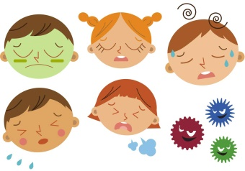
Under the current circumstances, we are having to be very strict about whether children can come in to Nursery or not. We must ask that parents DO NOT bring children in to Nursery or Playgroup if they are feeling unwell in any way. This is to reduce any risks for the other children and staff.

What if my child becomes ill while they are at school?

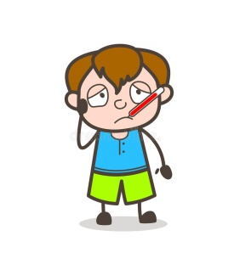
We will follow our usual procedures if your child becomes ill at school. We will request 2 emergency contacts from each family (including the mother and/or father of each child) This is so we can contact an emergency contact quickly to collect their child if they become unwell. We will have to be very strict about this. We need parents to make sure that anyone they have on their emergency contact list is fit, well and able to collect their child in an emergency. Parents will not be able to put anyone down as an emergency contact IF they are shielding, clinically vulnerable or extremely vulnerable.

What if my child or other staff and children in their Bubble show symptoms of coronavirus?

We have clear guidance on procedures to follow if anyone in Nursery/Playgroup shows symptoms of coronavirus while on site. If your child shows any symptoms of coronavirus, we will contact you immediately to collect them. We have a medical room for staff and children to use, where they can isolate until parents can collect them. Of course, staff will stay with children and care for them until parents/emergency contacts collect them.
We will get in touch with all parents of children who have had contact with anyone who shows symptoms of coronavirus and ask them to collect their child to take them home. This is so that we can prevent any further possible spread of infection. Children under the age of 5 can now be tested for coronavirus if they have symptoms and we will ask parents to make sure they take their child for a test before they return to school (if the child has shown symptoms). Similarly, any staff member who shows symptoms of coronavirus will have to take a test. Staff and children who have shown symptoms of coronavirus should only return to school if the test comes back negative.
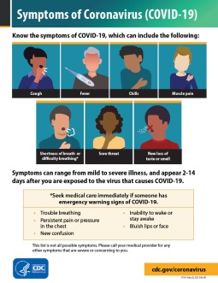
My child seems well enough, but another person in the family is showing symptoms
of coronavirus and is unwell, should I bring my child to Nursery/Playgroup?

No! If anyone in your family is showing signs or symptoms of coronavirus, they should have a test straight away. You and your child should self-isolate for 14 days and follow the guidance on www.gov.uk website. Your child should not return to Nursery/Playgroup unless the family member is tested and the result is negative.
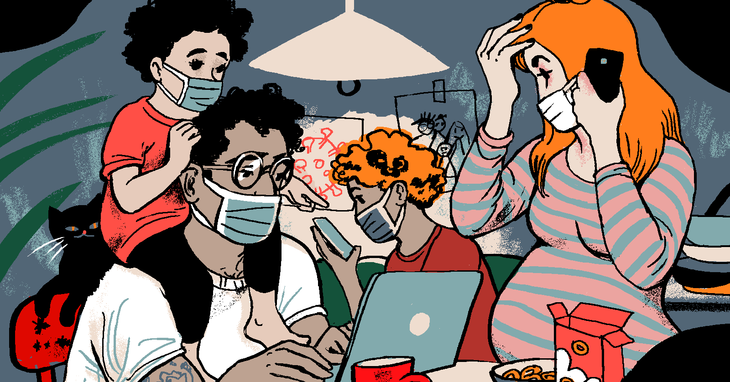
Someone in my family, who I live with is shielding or extremely vulnerable, should I
send my child back to Nursery/Playgroup?

No, this is not advised. Current guidance is still saying that children should not return to Nursery/Playgroup if they live in the same household as someone who is shielding or extremely vulnerable. www.gov.uk offers advice for parents/carers if they are worried about other members of the household becoming at risk when children return to schools. Nursery and Playgroup are non-statutory so it is up to parents/carers if they choose to send children back or not. We will NOT be following our usual attendance procedures if children are absent. Please give us a call or get in touch if you are worried about anything like this.
What should I do if I need to speak to my child’s teacher/keyworker/a member of staff before Nursery opens?

If you need to speak to staff before Nursery opens more fully, you can contact us by telephoning school on 0191 2654579. If the member of staff you wish to speak to is not available, we will take a message and they will call you back. You can also contact your child’s key worker by using the Class Dojo and leaving a message (Nursery parents only). You can also email admin@monkchesterroad.newcastle.sch.uk and Mrs. Grant will forward your message to the member of staff you need. If you have any questions, concerns or worries about your child returning to Nursery/Playgroup in June/July, please get in touch and we will be happy to answer your questions.

