**What will I do when I go back to Nursery?**

**What is different?**

A story to read to your children before they come back to Nursery

At Nursery, I will wait in line until it is time to go in the gates.



I will hold my mam’s hand all the time.

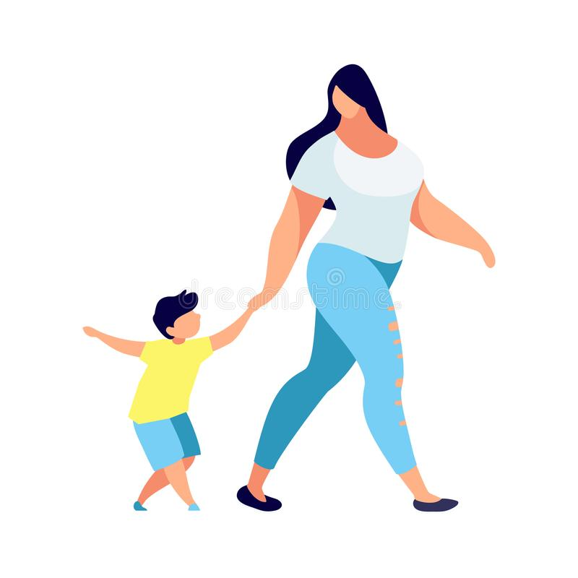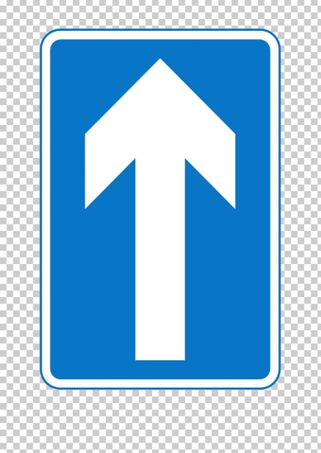

We will follow the arrows one way around to the garden.

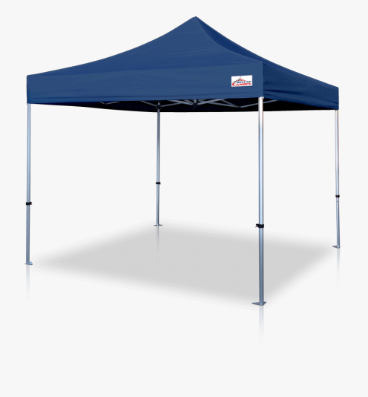

We will stop at the Gazebo with my teacher and friends.

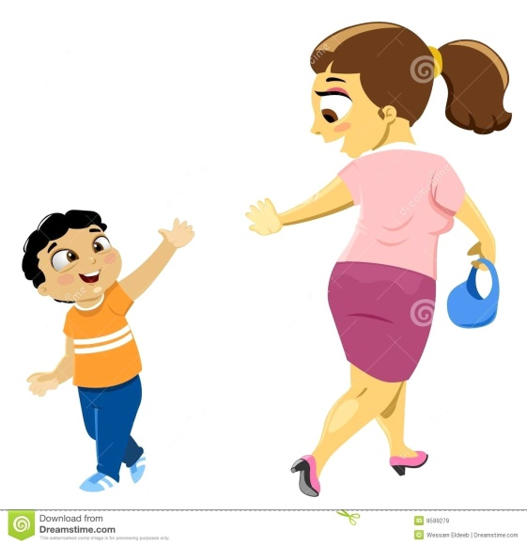

I will wave goodbye to my mam in the garden.

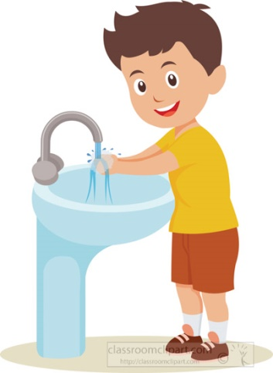

Inside, I will wash my hands.

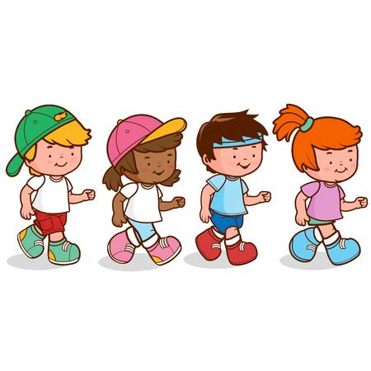

I will walk in to school in a line with my teacher and friends