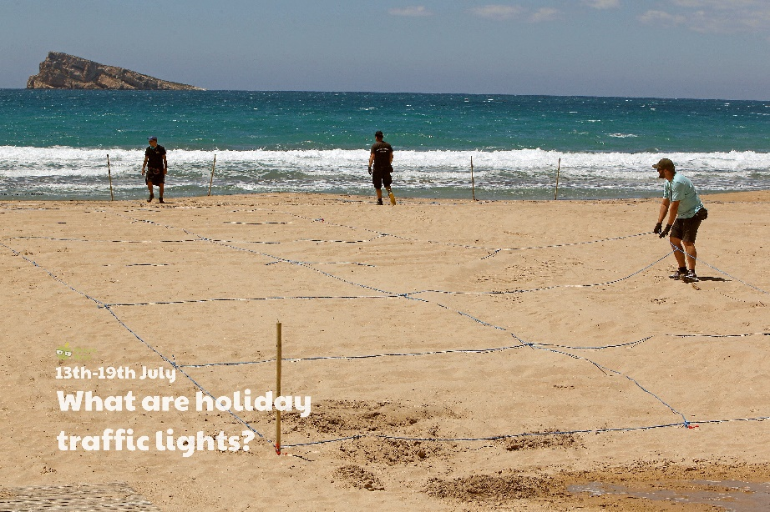

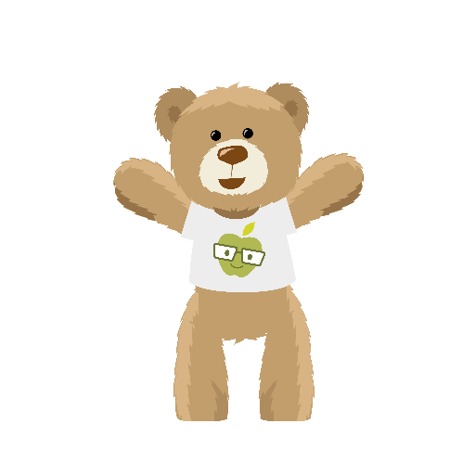
Use this sheet to let a grown-up write down all your thoughts on this week’s story.
- What can you see? Have you ever been to a beach before? If so, what did you do there? If you haven’t yet, would you like to go? What do you think you would enjoy doing?
- Can you think of some other countries people might like to travel to?
- What are traffic lights? What do the different colours on a traffic light mean?

